Government College University Faisalabad
Department of Software Engineering
BS in Software Engineering

Final Year Project
Project Title: Scientific Journal Publishing System
Course Code: BSSE-FYP
Session: 2022-2026
Sr. No. | Student Name | Roll No. | Email
1 | Emaan Ajmal | 222002 | emaanrandhawa002@gmail.com
2 | Sundus Mushtaq | 222013 | sundusmush@gmail.com
Supervisor: Dr. Sheraz
Designation: HOD & Associate Professor
Department: Software Engineering
Date of Submission: 24-12-2025

1. Problem Statement
Currently, many research journals and academic departments rely on manual or semi-manual processes for handling research paper submissions, peer review, and publication. These processes involve excessive email communication, lack of transparency, difficulty in tracking submission status, and increased workload for editors and reviewers. There is a need for an automated, centralized, and web-based system that can efficiently manage the entire research journal lifecycle.

2. Background Analysis
With the rapid growth of research activities in universities and academic institutions, the number of submitted research papers has increased significantly. Traditional journal management methods are time-consuming and prone to errors. Existing commercial journal systems are often expensive and complex. Therefore, an affordable, user-friendly, and locally customizable web-based journal publishing and peer review system is required.

3. Project Rationale / Motivation
The motivation of this project is to provide an automated platform that simplifies the journal publication process for authors, reviewers, and editors. This system aims to reduce manual effort, improve transparency, ensure timely reviews, and enhance the overall efficiency of academic publishing. The project also provides practical exposure to web development, database management, and software engineering concepts.

4. Developer and Target Users Aim and Objectives
The main aim is to develop a web-based automated research journal publishing and peer review system. Objectives include:
- To allow authors to submit research papers online
- To enable editors to manage submissions and assign reviewers
- To provide reviewers with an easy-to-use review interface
- To automate email notifications and status tracking
- To publish accepted papers in organized journal issues Target users include authors, reviewers, editors, and journal administrators.

5. Scope and Limitation of the Project
- Online paper submission and management
- Peer review and editorial workflow automation
- Role-based access control
- Journal issue and paper publishing
Limitations:
- DOI generation may not be implemented
- Advanced plagiarism detection tools may require third-party services
- The system is limited to web-based access only.

6. Proposed Software Models (Agile)
The Agile software development model will be used to develop this project. Agile allows incremental development, continuous feedback, and flexibility in accommodating changes during the development process.

7. System Design (List Conceptual Overviews)
The system consists of three main modules:
- Author Module: Registration, paper submission, revision upload, status tracking
- Reviewer Module: Review assignment, evaluation, comments submission
- Editor/Admin Module: User management, reviewer assignment, decision making, publishing.

8. Expected Outcomes / Anticipated Framework of Software
The final system will provide a fully functional web-based journal management platform with automated workflows. It will reduce manual workload, improve communication between stakeholders, and ensure a transparent peer review process.

9. Project Timeline (Gantt Chart)
- Requirement Analysis: Weeks 1–2
- System Design: Weeks 3–4
- Development: Weeks 5–10
- Testing: Weeks 11–12
- Documentation & Deployment: Weeks 13–14

10. Tools / Resources / AI resources
- Frontend: HTML, CSS, JavaScript
- Backend: NodeJS, Express JS
- Database: MongoDB
- Tools: VS Code
- AI Resources (Optional): Plagiarism checking APIs, grammar checking tools

11. Risk Assessment and Mitigation Plan
Risks include requirement changes, time constraints, and technical issues. These risks will be mitigated by regular meetings with the supervisor, proper planning, and incremental development using Agile methodology.

12. Similar Successful Projects (Optional)
- Open Journal Systems (OJS)
- Editorial Manager
- ScholarOne Manuscripts

13. Supervisor’s Remarks
______________________________________________________________________________________
______________________________________________________________________________________

Appendices (Actual/Proposed)
- Appendix A: System Diagrams (Use Case)

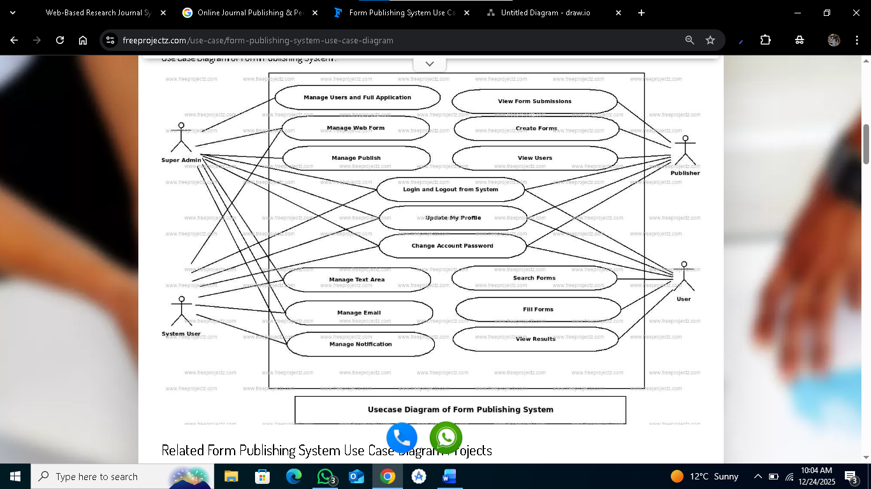

- Appendix B: Interface Mockups / Screenshots
